**SMILE CUSTOMER REGISTRATION**

**PROCESS FLOW**

**Table of Contents**

**1.** **SIM Card Registration Process FlowChart** 3

**2.** **Registration of Nationals:** 4

**3.** **Device and/or SIM card Sale (for Nationals):** 7

**4.** **Registration of Foreigners & Refugees:** 10

**5.** **SIM Card Swap for Lost SIM cards** 12

**6.** **SIM Card Swap for Faulty SIM Cards** 13

# **SIM Card Registration Process FlowChart**

# 

Yes

No

**If Compliant**

**Step 5**

**CC KYC agent Reviews & Validates customer Bio Data**

**Step 3**

**Sales Person completes customer bio data review & SEP registration**

**If National**?

**Step 4**

**SEP submits customer data to NIRA for Verification**

**Step 7**

**Physical KYC Form Delivered to HQ**

**Step 1**

**Scan Barcode on National ID**

**Step 6**

**SIM Activation**

No

**Sales Person/Customer updates required details**

No (*Foreigner/Refugee*)

(Foreigner

Yes

Yes

No

**If Match?**

No

**Step 2**

**Scan Finger Print to validate owner**

**If Match**?

Yes

**If National?**

Yes

# **Registration of Nationals:**

1. 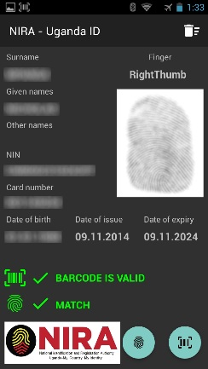New Ugandan customer walks to retail / sales outlet to purchase device and/or a SIM card
2. Presents his or her original National ID to the salesperson.
3. Salesperson scans the bar code on the back of the national ID card using the card reader to verify its authenticity
4. Then scans the customer’s fingerprint using the fingerprint scanner to validate rightful ownership of the presented national ID
5. If the fingerprint match is successful, takes a screen shot of the Screen Verification on the card reader
6. Takes a clear facial photograph of the customer and also scan the national ID.
7. In SEP (**Smile Enterprise Portal**), salesperson registers the customer by capturing the following bio-data: *Title, Surname, Given Name, Date of Birth, Gender, Nationality, ID Type, NIN, ID Card number, Email address, Contacts, Physical Address, Username*

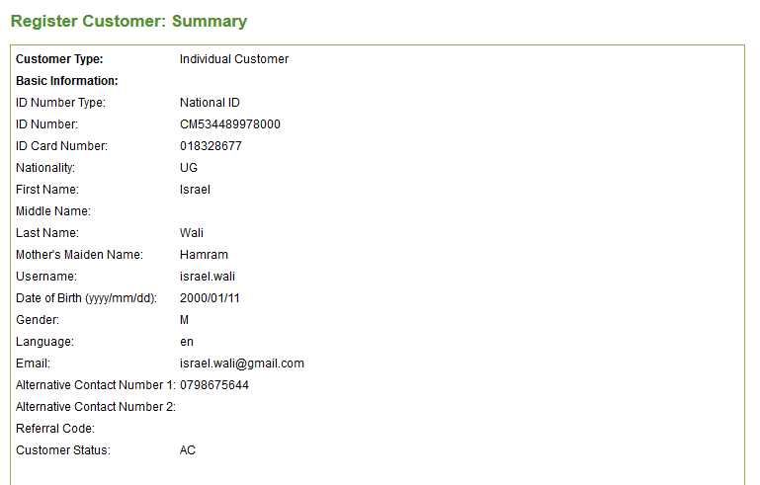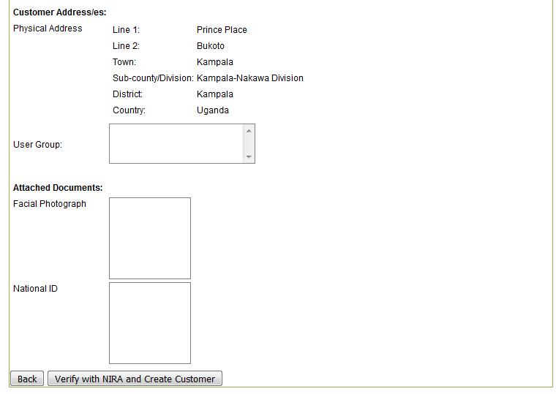

1. **100% ACCURACY in capturing the National ID biodata is critical to ensure successful NIRA verification**.
2. The Salesperson also uploads the Customer Photograph, fingerprint and scanned copies of the National ID and the SIM Registration Form
3. After entering / uploading all required information, Salesperson clicks on the *“Verify with NIRA/Create Customer”* button
4. At that point, SEP remits selected customer information via NIRA API for verification of the National ID (*Surname, Given Name, Document No., NIN, DOB*)
5. NIRA Response:
   1. If NIRA validation is successful, the customer’s profile is automatically created in SEP.

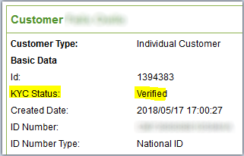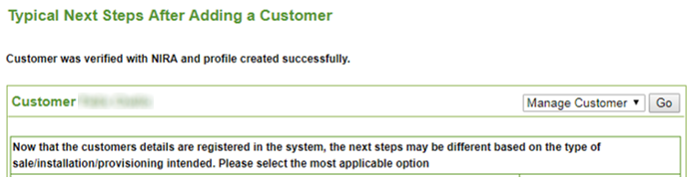

On the Customer Profile, the KYC Status will be set to “*Verified*” and the Salesperson can proceed to sell the device or SIM card to the customer.

* 1. 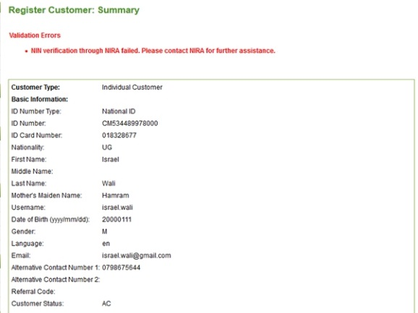If NIRA validation is unsuccessful, SEP will display an error: “*NIN verification through NIRA failed. Please contact NIRA for further assistance*”.
  2. Salesperson can retry the verification in case of a data entry error. If still unsuccessful, salesperson DOES NOT proceed with the device and/or SIM card sale and advises the customer to engage NIRA regarding their national ID status.
  3. Data entered in SEP during the customer registration will be discarded after unsuccessful NIRA verification.

1. After successful NIN verification *(12a. above)* and the device or SIM card sale is made, the SIM card is provisioned on the customer’s profile but remains with status *“TD” (Temporarily Deactivated)* until Customer Care KYC Team verification of the customer registration is done.

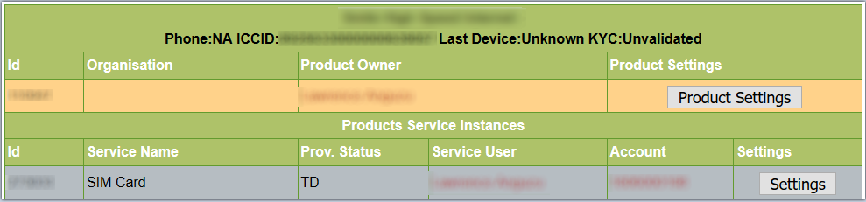

1.  Every device and/or SIM card sale is flagged onto the Customer Care KYC Team real-time dashboard (at Head Office).

* The KYC team then reviews and validates the customer’s captured bio-data, photograph, national ID and the SIM Registration Form to make sure that the required information has been provided by the customer and has been correctly captured by the Salesperson.
* If there are any registration discrepancies, the SIM card is NOT activated and the Salesperson is notified immediately to make the required corrections with the customer and revert back to the KYC team. Once the corrections are re-evaluated and pass as per the guidelines, the SIM card is then activated.

1. If the registration and verification has been correctly done the first time as per UCC guidelines, the KYC team activates the customer’s SIM card by changing the KYC statusat the SIM card level to *“Complete - NIN verified”*

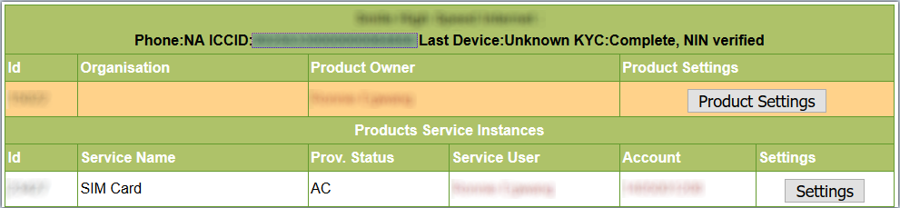

After SIM card activation, the customer’s physical subscriber form is remitted to Head Office for filing.

# **Device and/or SIM card Sale (for Nationals):**

1. Smile customer walks to retail outlet to purchase a device and/or SIM card
2. Presents his or her original National ID to the salesperson.
3. Salesperson scans the bar code on the back of the national ID card using the card reader to verify the ID’s authenticity
4. Then scans the customer’s fingerprint using the fingerprint scanner to validate rightful ownership of the presented national ID
5. If the fingerprint match is successful, a screen shot of the Fingerprint Match on the card reader is taken.
6. On the customer’s Profile, the salesperson selects the *“Make Sale”* option from the *“Edit”* drop down menu. (For a new customer, after successful registration, one clicks on *“Make a Sale”* button on the *“Next Steps”* page)
7. Then selects the customer’s account under *“Private Individual”*
8. On the *“Sale Items”* window, salesperson selects the required device kit (Mi-Fi or Router or SIM-only KIT)
9. Then clicks on *“Submit for Pricing”* button.
10. SEP will then check the *KYC Status* on the Customer’s profile:
    1. 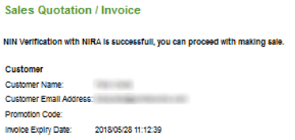If the *KYC Status* is *“Verified”*, SEP will automatically pick the required customer information for NIRA verification and remit it to NIRA (*Last/Surname, First/Given Name, ID Card No., NIN, DOB*). After successful NIRA verification, salesperson can proceed to make the device and/or SIM card sale.
    2. 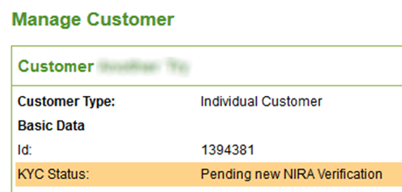If the *KYC Status* on the Customer’s Profile is *“Pending New NIRA Verification”*, SEP will open the *“Edit Customer”* page.
    3. Salesperson will then enter the blank fields with the biodata from the customer’s National ID (*Last/Surname, First/Given Name, ID Card No., NIN, DOB*) and click on *“Update”* button
    4. SEP will remit the above information to NIRA for verification
    5. If verification is successful, the customer’s profile will be updated with the NIRA verified information and the *KYC Status* will be set to *“Verified”*

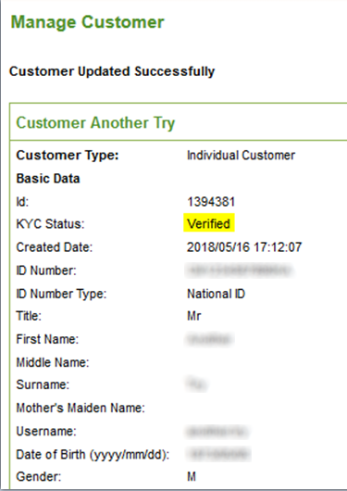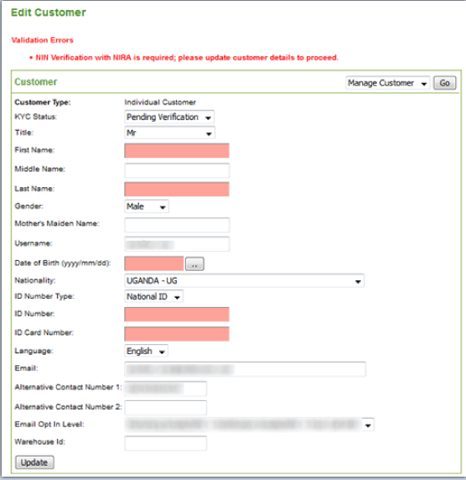

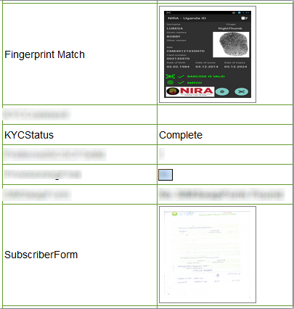

* 1. After successful NIRA verification, salesperson can proceed to finalize the device and/or SIM card sale
  2. When provisioning the SIM card, the salesperson uploads both the *Subscriber Registration Form* and the *Fingerprint Match* screenshot (from the card reader) against the respective customer SIM card.

1. After successful NIN verification and the device and/or SIM card sale is made, the SIM card is provisioned on the customer’s profile but remains with status “TD” (Temporarily Deactivated) until KYC Team verification of the customer registration is done.



1.  Every device and/or SIM card sale is flagged onto the Customer Care KYC Team real-time dashboard (at Head Office).

* The KYC team then reviews and validates the customer’s captured bio-data, photograph, national ID and the SIM Registration Form to make sure that the required information has been provided by the customer and has been correctly captured by the Salesperson.
* If there are any registration discrepancies, the SIM card is NOT activated and the Salesperson is notified immediately to make the required corrections with the customer and revert back to the KYC team. Once the corrections are re-evaluated and pass as per the required guidelines, the SIM card is then activated.

1. If the registration and verification has been correctly done the first time as per UCC guidelines, the KYC team activates the customer’s SIM card by changing the KYC status at the SIM card level to “Complete - NIN verified”



After SIM card activation, the customer’s physical subscriber form is remitted to Head Office for filing.

# **Registration of Foreigners & Refugees:**

1. New foreigner customer walks to retail / sales outlet to purchase device or SIM card
2. Presents his or her original ID to the salesperson (Passport or Refugee ID/OPM Letter)
3. The Salesperson verifies the validity of the ID/documents provided by the customer by looking at:
   1. Whether the customer matches the facial photo on the passport and the visa
   2. The issuing and expiry dates of the passport / Refugee ID and its corresponding visa to confirm validity
4. If the above are fine, Salesperson takes a clear facial photograph of the customer and scans their fingerprints.
5. In SEP (**Smile Enterprise Portal**), Salesperson registers the customer by capturing the following bio-data: *Title, Surname, Given Name, Date of Birth, Gender, Nationality, ID Type, ID number, Passport expiry date, Visa expiry date, Email address, Contacts, Physical Address, Username*
6. The Salesperson also uploads the Customer Photograph, fingerprint image and scanned copies of the ID, visa and the SIM Registration Form
7. After entering / uploading all required information, Salesperson clicks on the *“Create Customer”* button, then proceeds to sell the device or SIM card.
8. After successful NIN verification and the device or SIM card sale is made, the SIM card is provisioned on the customer’s profile but remains with status “TD” (Temporarily Deactivated) until KYC Team verification of the customer registration is done.



1.  Every device and/or SIM card sale is flagged onto the Customer Care KYC Team real-time dashboard (at Head Office).

* The KYC team then reviews and validates the customer’s captured bio-data, photograph, ID and the SIM Registration Form to make sure that the required information has been provided by the customer and has been correctly captured by the Salesperson.
* If there are any registration discrepancies, the SIM card is NOT activated and the Salesperson is notified immediately to make the required corrections with the customer and revert back to the KYC team. Once the corrections are re-evaluated and pass as per the required guidelines, the SIM card is then activated.

1. If the registration and verification has been correctly done the first time as per UCC guidelines, the KYC team activates the customer’s SIM card *(AC)* and sets the KYC status at the SIM card level to *“Complete”*.

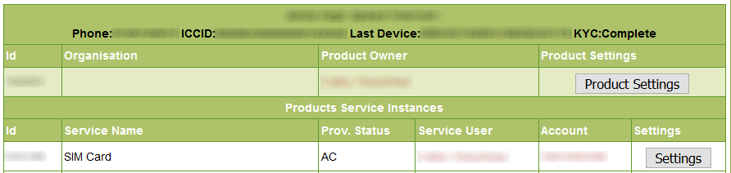

After SIM card activation, the customer’s physical subscriber form is remitted to Head Office for filing.

# **SIM Card Swap for Lost SIM cards**

Ensure the card reader is always connected to the Retail Outlet laptop

Customer walks into the Retail outlet and requests to swap/replace their SIM. The following should be undertaken:

1. Request for the **original** National ID or Passport and the Police Report for the lost SIM card. If both are not available, request the customer to return with both in order to process the SIM swap
2. Log into SEP and check if the customer is an existing Smile customer
3. Confirm if the lost SIM card indicated on the Police report is registered in the customer’s name in SEP
4. If yes, inform the customer of the cost of the new SIM card and confirm with the customer if you can proceed with the swap process. If SIM is not registered to that customer, inform them and request them to have the rightful owner of the SIM card to come and process the SIM swap

**ONLY IF THE ABOVE IS PASSED SHOULD YOU PROCEED WITH THE VERIFICATION/SIM SWAP PROCESS**

1. If customer is a **foreigner**, proceed to step **5(i).** If Ugandan, scan the bar code on the back of the national ID and verify its authenticity using the card reader
2. Scan the customer’s fingerprint to validate rightful ownership of the presented national ID
3. If match is successful, take a screen shot of the Verification Screen on the card reader
4. If the verification is unsuccessful, kindly inform the customer that the national ID cannot be verified hence the SIM swap cannot be done. Advise them to contact NIRA for additional support
5. Once the national ID is verified, proceed with the steps below:
6. Fill out the Subscriber Registration Form for the new SIM card, have it signed off and scan it
7. Fill out the SIM Swap Form, have it signed and scan it
8. Take a photo of the customer
9. Take a scan of the National ID or Passport and the Police Report
10. Copy the card reader verification screenshot image from the card reader memory via your laptop
11. Email all the above information to Customer Care KYC Team at Head Office ([kyc-ug@smilecoms.com](mailto:kyc-ug@smilecoms.com)) requesting for approval to swap the customer’s lost SIM card
12. Once KYC team has approved, proceed to make the sale of the new SIM card. Then:

* Fill in the Sale ID into the SIM swap form
* Email the sale ID to KYC team

1. KYC team will then do the SIM swap
2. After the SIM swap, hand over the new SIM card to the customer
3. Assist the customer with any other query they may have

# **SIM Card Swap for Faulty SIM Cards**

Ensure the card reader is always connected to the Retail Outlet laptop

Customer walks into the Retail outlet and requests to swap/replace their SIM. The following should be undertaken:

1. Request for the **original** National ID or Passport and the physical faulty SIM card. If both are not available, request the customer to return with both in order to process the SIM swap
2. Log into SEP and check if the customer is an existing Smile customer
3. Confirm if the faulty SIM card presented is registered in the customer’s name in SEP
4. If yes, inform the customer of the cost of the new SIM card and confirm with the customer if you can proceed with the swap process. If SIM is not registered to that customer, inform them and request them to have the rightful owner of the SIM card to come and process the SIM swap.

**ONLY IF THE ABOVE IS PASSED SHOULD YOU PROCEED WITH THE VERIFICATION/SIM SWAP PROCESS**

1. If customer is a **foreigner**, proceed to step **5(i).** If Ugandan, scan the bar code on the back of the national ID and verify its authenticity using the card reader
2. Scan the customer’s fingerprint to validate rightful ownership of the presented national ID
3. If match is successful, take a screen shot of the Screen Verification on the card reader
4. If the verification is unsuccessful, kindly inform the customer that the national ID cannot be verified hence the SIM swap cannot be done. Advise them to contact NIRA for additional support
5. Once the national ID verified, proceed with the steps below:
6. Fill out the Subscriber Registration Form for the new SIM card, have it signed off and scan it
7. Fill out the SIM Swap Form, have it signed and scan it
8. Take a fresh photo of the customer
9. Take a scan of the National ID or Passport
10. Take a photo of the faulty SIM card with ICCCID clearly seen. Where the ICCID is not visible, put the SIM in a device and access the device URL via your laptop. Take a screenshot of the URL page showing the ICCID of the faulty SIM
11. Copy the card reader verification screenshot image from the card reader memory via your laptop
12. Email all the above information to Customer Care KYC Team at Head Office ([kyc-ug@smilecoms.com](mailto:kyc-ug@smilecoms.com)) requesting for approval to swap the customer’s lost SIM card
13. Once KYC team has approved, proceed to make the sale of the new SIM card.

* Fill in the Sale ID into the SIM swap form
* Email the sale ID to KYC team

1. KYC team will then do the SIM swap
2. Hand over the new SIM card to the customer
3. Assist the customer with any other query they may have.